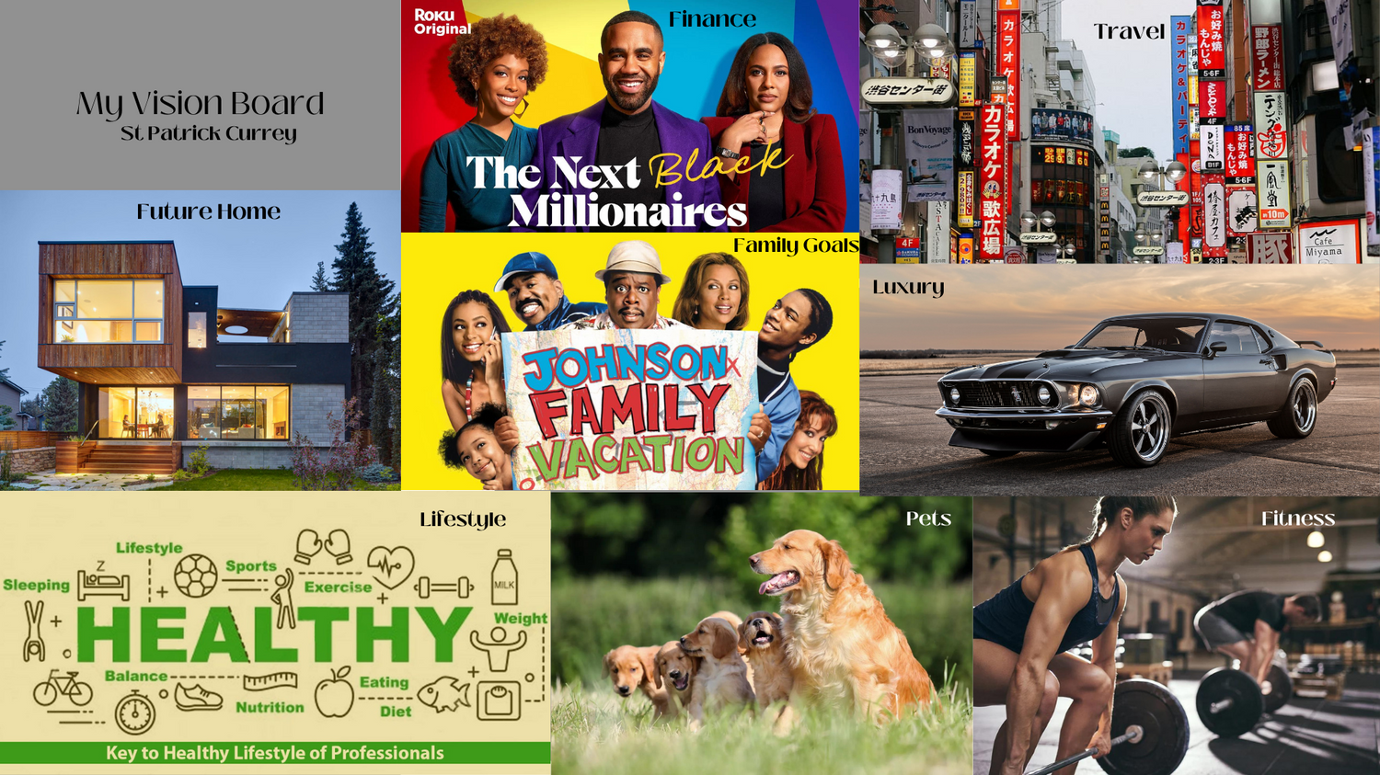

**Roku Original**

Finance

**カラオケ**

Travel

**カラオケ歌広場**

**野郎ラーメン テング**

お好み焼

お好み焼 NALQO

BIBIBIBR

Cafe

Miyama

Pets

Fitness

**Sleeping**

+

My Vision Board St Patrick Currey

Future Home

**Lifestyle**

**Sports**

The Next Black Millionaires

Lifestyle

Family Goals

JOHNSON FAMILY VACATION

E

**Weight**

Exercise 0=0 MILK

**HEALTHY**

**Balance**

O

**Nutrition**

**Eating**

Diet

**Key to Healthy Lifestyle of Professionals**

渋谷センター街

**Bon Voyage**

七十九島

Luxury